**Question 1**

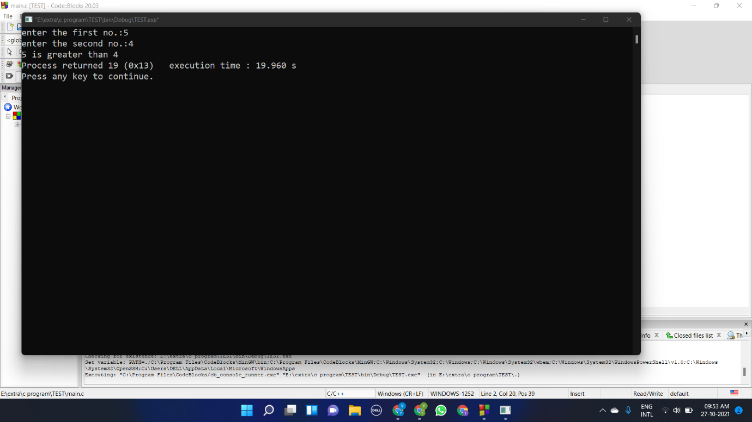#include <stdio.h>

#include <stdlib.h>

void main()

{

int a,b;

printf("enter the first no.:");

scanf("%d",&a);

printf("enter the second no.:");

scanf("%d",&b);

if (a>b) printf("%d is greater than %d",a,b);

else if (a=b)printf("both no are equal");

else printf("%d is greater then %d",b,a);

}

**Question 2**

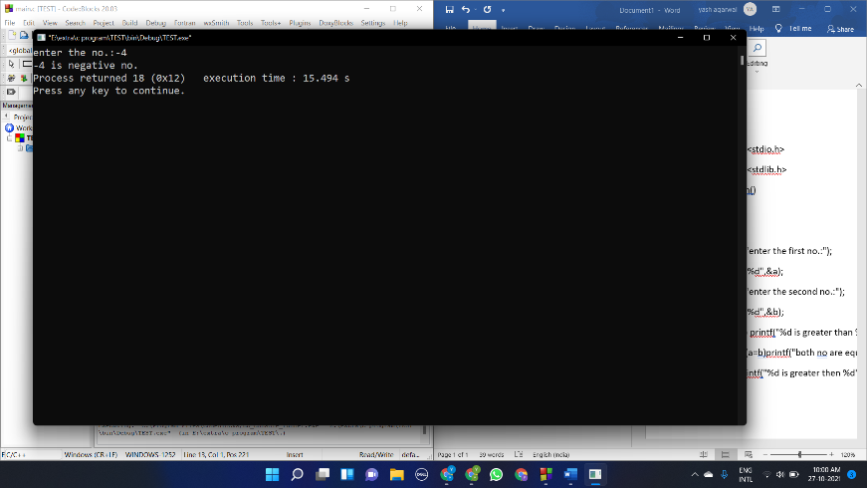#include <stdio.h>

#include <stdlib.h>

void main()

{

int a;

printf("enter the no.:");

scanf("%d",&a);

if (a>=0) printf("%d is a positive no.",a);

else printf("%d is negative no.",a);

}

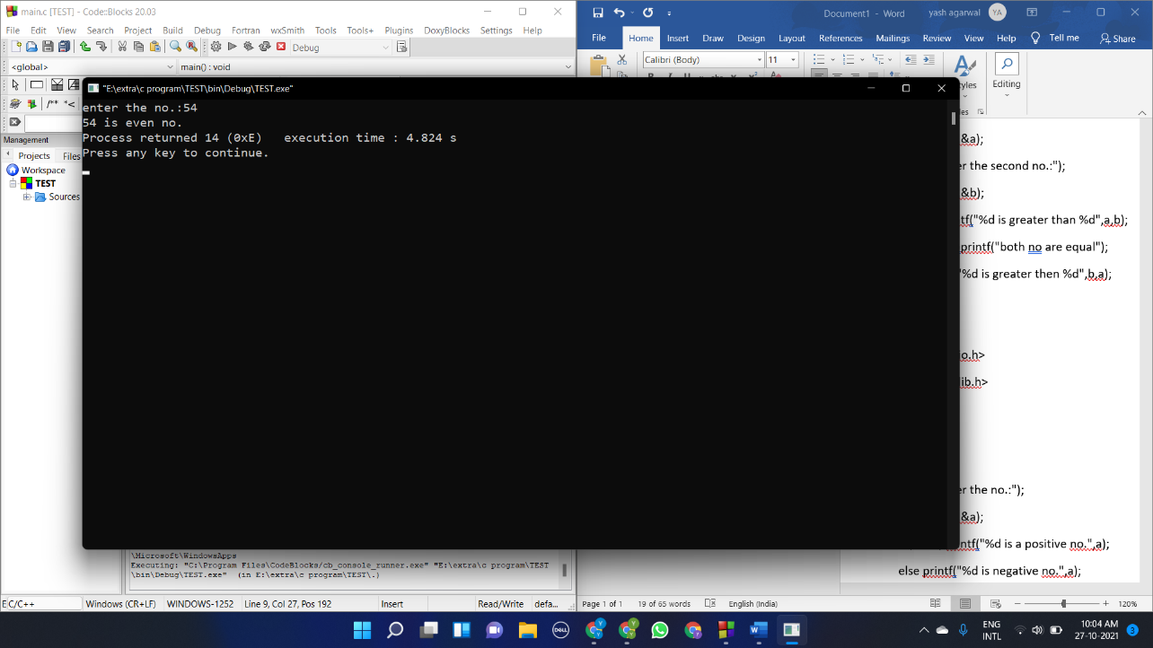**Question 3**

#include <stdio.h>

#include <stdlib.h>

void main()

{

int a;

printf("enter the no.:");

scanf("%d",&a);

if (a%2==0) printf("%d is even no.",a);

else printf("%d is odd no.",a);

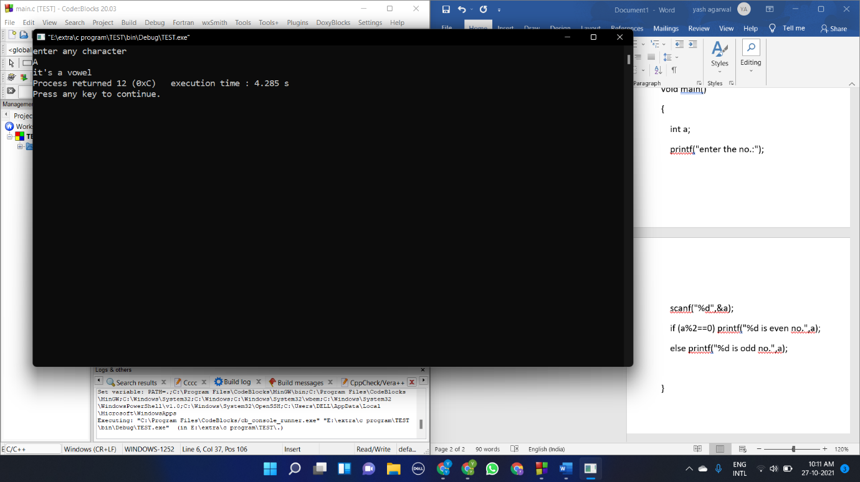}

**Question 4**

#include <stdio.h>

#include <stdlib.h>

void main()

{

char a;

printf("enter any character\n");

scanf("%c",&a);

if(a=='a' || a=='e'|| a=='i' || a=='o' || a=='u') printf("it's a vowel");

else if (a=='A' || a=='E'|| a=='I' || a=='0' || a=='U') printf("it's a vowel");

else printf("it's a consonant");

}

**Question 5**

#include <stdio.h>

#include <stdlib.h>

void main()

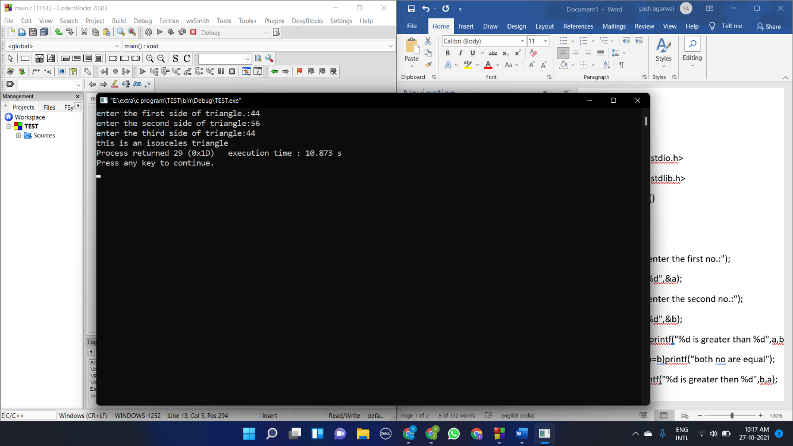{

int a,b,c;

printf("enter the first side of triangle.:");

scanf("%d",&a);

printf("enter the second side of triangle:");

scanf("%d",&b);

printf("enter the third side of triangle:");

scanf("%d",&c);

if(a+b<c || c+b<a || a+c<b) printf("this is not a triangle");

else if(a==b && a==c) printf("this is an equilateral triangle");

else if (a==b || a==c|| b==c) printf("this is an isosceles triangle");

else printf("this is a scalane triangle");

}

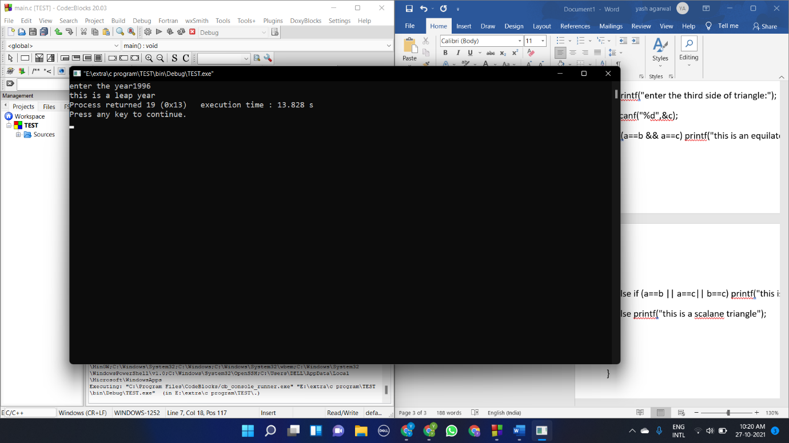**Question 6**

#include <stdio.h>

#include <stdlib.h>

void main()

{

int a;

printf("enter the year");

scanf("%d",&a);

if(a%4==0) printf("this is a leap year");

else printf("this is not a leap year");

}

**Question 7**

#include <stdio.h>

#include <stdlib.h>

void main()

{

int a,b,c;

printf("enter the first no.:");

scanf("%d",&a);

printf("enter the second no.:");

scanf("%d",&b);

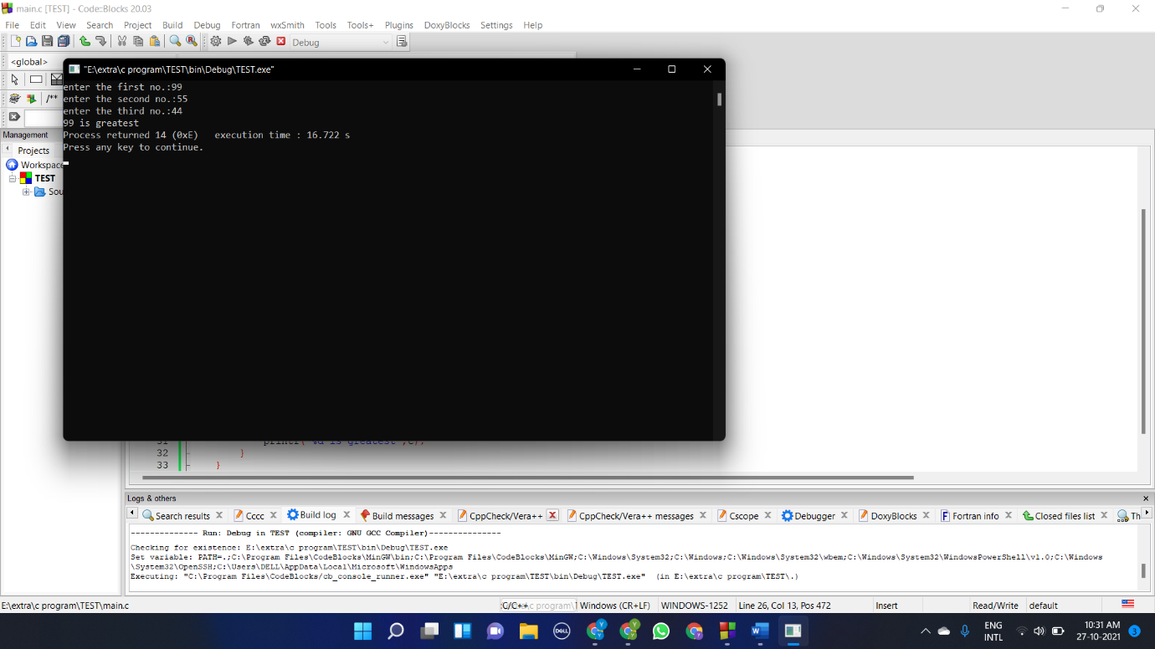 printf("enter the third no.:");

scanf("%d",&c);

if(a>b)

{

if (a>c)

{

printf("%d is greatest",a);

}

else

{

printf("%d is greatest",c);

}

}

else if(b>a)

{

if (b>c)

{

printf("%d is greatest",b);

}

else{

printf("%d is greatest",c);

}

}

}

**Question 8**

#include <stdio.h>

#include <stdlib.h>

void main()

{

int a;

float amount,sub_charge,bill;

printf("enter the unit:");

scanf("%d",&a);

amount=100;

if (a<=50)

{

float amt;

amt = 0.5*a;

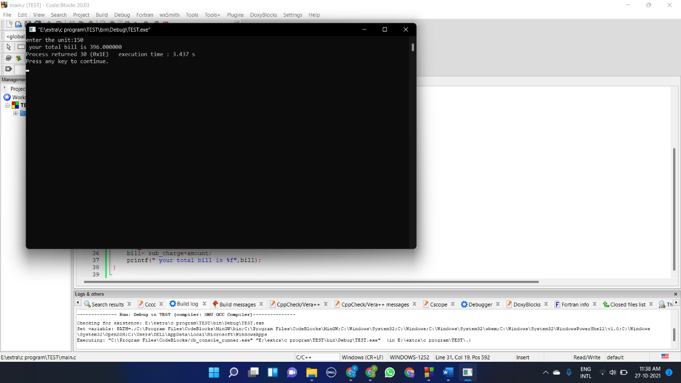

amount = amount+amt;

}

else if (a>50 && a<=150)

{

float amt;

amt = (0.75*(a-50))+ (0.5*50);

amount= amount+amt;

}

else if (a>150 && a<=250)

{

float amt;

amt = (1.2*(a-150))+(0.75*100)+ (0.5*50);

amount= amount+amt;

}

else;

{

float amt;

amt = (1.5*(a-250))+(1.2*150)+(0.75*100)+ (0.5*50);

amount= amount+amt;

}

sub_charge=amount*0.2;

bill= sub_charge+amount;

printf(" your total bill is %f",bill);

}

**Question 9**

#include <stdio.h>

#include <stdlib.h>

void main()

{

int a,b,c;

printf("enter the amount:");

scanf("%d",&a);

while (a !=0)

{

if (a>=500)

{

int d;

d=a/500;

printf("%d * 500 rupees notes\n",d);

a=a-500*d;

}

else if (a>=100)

{

int d;

d=a/100;

printf("%d * 100 rupees notes\n",d);

a=a-100*d;

}

else if (a>=50)

{

int d;

d=a/50;

printf("%d * 50 rupees notes\n",d);

a=a-50*d;

}

else if (a>=20)

{

int d;

d=a/20;

printf("%d * 20 rupees notes\n",d);

a=a-20*d;

}

else if (a>=10)

{

int d;

d=a/10;

printf("%d * 10 rupees notes\n",d);

a=a-10*d;

}

else if (a>=5)

{

int d;

d=a/5;

printf("%d * 5 rupees notes\n",d);

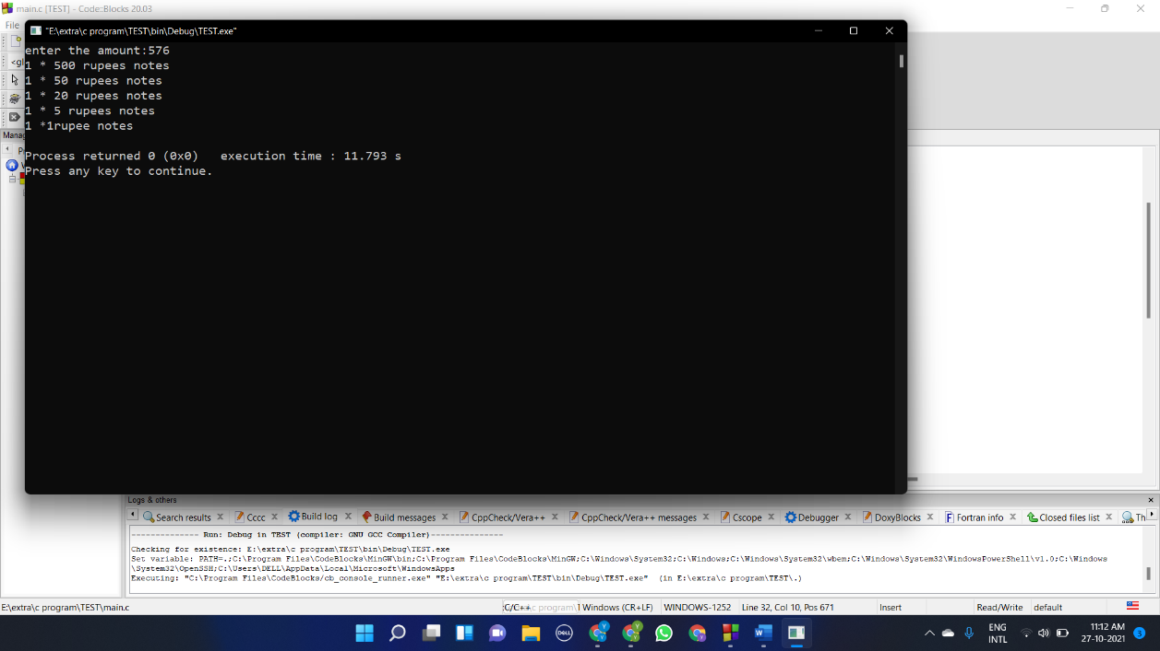 a=a-5*d;

}

else if (a>=2)

{

int d;

d=a/2;

printf("%d * 2 rupees notes\n",d);

a=a-2*d;

}

else

{

int d;

d=a/1;

printf("%d *1rupee notes\n",d);

a=a-1*d;

}

}

}

**Question 10**

#include <stdio.h>

#include <stdlib.h>

void main()

{

float gross,basic,da,hra;

printf("enter the basic salary:");

scanf("%f",&basic);

if (basic>= 20001)

{

hra=0.3*basic;

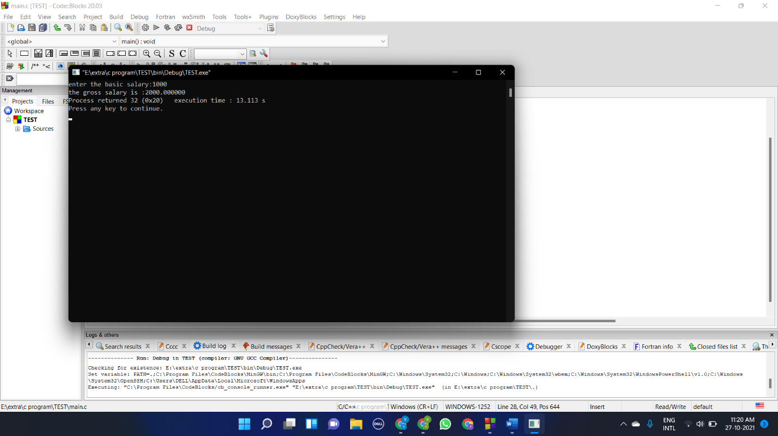 da=0.95*basic;

gross=basic+hra+da;

printf("the gross salary is :%f",gross);

}

else if (basic>=10001&& basic<2000)

{

hra=0.25*basic;

da=0.90*basic;

gross=basic+hra+da;

printf("the gross salary is :%f",gross);

}

else

{

hra=0.2*basic;

da=0.8*basic;

gross=basic+hra+da;

printf("the gross salary is :%f",gross);

}

}